



Your Financial Plan
Stacey Shipman


Prepared by Roshan Tamil
Chartered Financial Planner
10th March 2023
AAI Is Authorised and Regulated by the Financial Conduct Authority

Contents
1) Your Annual Financial Review 1
2) Recommendation Summary 2
3) Your Objectives 3
4) Your Risk Profile 4
5) Your Plans 6
6) Planning Ahead 7
7) Recommendations 14
8) What Are The Charges 17
9) Other Areas of Planning 19
10) Next Steps 20
Appendix - Risk Profile Assessment 21
Appendix - Your Existing Plans 23
Appendix - Product Information 26
Appendix - LIFT-Invest Additional Information 28

Your Annual Financial Review

Introduction
It is important we regularly review your financial affairs to ensure you remain on track to meet your financial objectives and we can continue to act in your best interests.

This report provides an update on your current circumstances, and a review of your objectives and existing plans that are managed by my company to ensure they remain suitable for your needs, objectives and risk profile.

Circumstances
I note the following changes have taken place with regards to your circumstances since our last review:

You recently purchased a house in Nairn, which has become your main residence.
You subsequently sold Cherry Cottage, your previous main residence. This raised proceeds of approximately c.£338,000.

Understanding You
The advice we provide is based on the information you have provided about your personal and financial circumstances. If this report does not accord with your view of the situation or you require further clarification, please contact me immediately. We retain full details of this information and notes of our conversations on file.

LIFT-Financial Contacts
At LIFT-Financial, each client has access to a team of individuals who will support them. The team that will be looking after you is:

Chartered Financial Planner | Roshan Tamil FPFS
Technical Support Analyst | Jacob DipPFS
Head of Group Risk | Jonathan APFS
Senior Client Support | Angela Leigh
Client Support | Abigail Jones

As you know, I am your direct point of contact for any queries. However, in the event that you are unable to reach me please do not hesitate to contact my Client Support in the first instance on 0161 929 2626.

Recommendation Summary
I would advise that you read the full ‘Recommendations’ section later in this report to understand the reasoning behind my recommendations. However, these can be summarised as follows:
Owner | Plan | Recommendation
Stacey Shipman | AJ Bell Investcentre ISA | - Invest £150,000 into your ISA in the current 2022/23 tax year.  - This is to be invested into the LIFT-Invest Moderately Cautious portfolio.  - This will be funded by the proceeds of your property sale.  - As AJ Bell Investcentre ISAs are ‘flexible’, this will be treated as replacing the £150,000 that was withdrawn in September 2022.  - This has already been covered in a short suitability letter. You have confirmed your acceptance to the recommendation, and the funds have been invested.
Stacey Shipman | AJ Bell Investcentre SIPP | - I recommend no changes
Stacey Shipman | AJ Bell Investcentre GIA | - I recommend no changes
Stacey Shipman | Baillie Gifford Final Salary Scheme | - I recommend no changes

Your Objectives

Background
This report is further to our recent meeting on 17th January 2023 where we discussed your financial goals and objectives. I agreed to provide a report which summarises your financial position and highlights areas that may require further attention.

Objectives
We discussed your personal and financial circumstances and explored what you were trying to achieve. We then helped you to form these into the prioritised objectives outlined below:

To meet your desired expenditure of £48,120 in retirement
We have predicted that you will require approximately c.£48,120 in retirement. You have substantial guaranteed income provided by the Baillie Gifford Final Salary Scheme, and the State Pension. You also have some regular rental income provided by the London flat. Any shortfall will be addressed by withdrawing from your savings and investments, and then from your AJ Bell Investcentre SIPP.

To use your resources to provide any discretionary lump sums and enjoy retirement.
Cashflow analysis suggests that you should not run out of money, even when considering the effect of a major loss, or extra spending on ‘wild living’. This means you can afford to take discretionary lump sums to fund things such as holidays, so that you can enjoy retirement.

To realise capital held in the London buy-to-let property.
You own and manage a rental property in London. A sale of this property will help to provide capital for retirement, however you are not certain of the time horizon for this objective. The mortgage fixed rate expires in February 2024, at which point, you plan to pay off the mortgage, and decide whether to sell the property, or continue letting.

My recommendations outlined later in this report are based on these objectives. Therefore, if you do not feel that these accurately reflect your goals and needs, please contact me at your first convenience prior to proceeding with any recommendations made.

Other Needs & Shortfalls
As holistic financial planners, we believe it is important to review all areas of your finances in order to identify any shortfalls or areas for improvement. This is a vital component of the financial planning process as it highlights areas that, if not addressed, could have a serious impact on your lifestyle and financial wellbeing.

Consequently, we identified the following other areas that you have a need or shortfall, although they have not been addressed in this report for the reasons outlined below:

Need or shortfall | Reason not being addressed now
Inheritance Tax Planning | I have pointed out that, if you died today, your estate would have an IHT liability of approximately c.£911,988 Whilst you understand this you did not want to do anything about it yet, as IHT will be mitigated by spending throughout retirement.

If you decide you require advice in relation to any of these areas before our next annual review meeting, or on any other matter, please get in touch.

Your Risk Profile
We revisited the concept of risk and reward during our recent meeting i.e. that an element of risk is needed to improve potential returns on your investment, and ultimately to achieve your objectives. We also reviewed your risk profile against the context of your objectives.

You completed a Risk Tolerance Questionnaire in October 2021, suggesting that you are a ‘Moderate’ investor. A previous questionnaire returned a result of Moderately Cautious.

You worked with investments throughout your career, most recently at Blackrock, where you worked for 10 years as Head of Product Strategy. Whilst you were not dealing in investments explicitly, you had a lot of exposure to investments, meaning that you should have more knowledge and experience than the average person.

Funds are to remain invested throughout retirement, for potentially more than 30 years, meaning that the investment time horizon is long-term.

Cashflow analysis suggests that you can afford to suffer a loss of up to 99.06% and still achieve your goals, this is partly because of your substantial guaranteed income from your state pension and defined benefit scheme, in addition to your rental income. You therefore have a high capacity for loss.

Due to the above factors, we have agreed that a Moderately Cautious approach will be appropriate, as you do not need to take excessive risk in order to achieve your goals.

Risk Scale

Low Risk |  |  |  | High Risk
Cautious | Moderately Cautious | Moderate | Moderately Adventurous | Adventurous

Please see ‘Appendix – Risk Profile Assessment’ at the end of this report for more details of the assessment we undertook and the definitions for each risk profile.

 | When investing your capital is at risk. Past performance is not an indicator of future results and future returns are not guaranteed.

Cash Reserves
In order for you to take investment risk, I would typically recommend the equivalent of three to six month's expenditure is kept within an instant access deposit account, to act as an emergency fund. I have reviewed your cash emergency fund and confirm the previous and current amounts below.

Existing Amount | Amount Post-Recommendation
£238,000.00 | £88,000

We agreed this is sufficient given your circumstances and objectives. I confirm my recommendations are therefore affordable for you both now and for the foreseeable future.

 | Please note, the Financial Services Compensation Scheme (FSCS) only protects up to £85,000 of holdings with any one banking organisation. This means that if you were to hold more than £85,000 with any one banking organisation, and that organisation was then to get into financial difficulty, you may not be able to recover all of your holdings. You should therefore consider spreading your cash savings across multiple banking organisations.  See the Product Information Appendix for more information.

Your Plans
Please see the table below for a summary of the plans that we manage for you. We have discussed these plans and the table below shows their position before my recommendations are implemented.

Owner | Plan | Investment/Portfolio | Values*
Stacey Shipman | AJ Bell Investcentre - ISA | LIFT-Invest Moderately Cautious | £146,831.74
Stacey Shipman | AJ Bell Investcentre - SIPP | LIFT-Invest Moderately Cautious | £465,333.97
Stacey Shipman | AJ Bell Investcentre - General Investment Account | Cash | £1,356.09
Total: |  |  | £470,150.35
*As at 18/01/2023

A full breakdown of these portfolios can be found in ‘Appendix – Your Existing Plans’ at the end of this report. My recommendations regarding these plans can be found in the ‘Recommendations’ section of this report.

 | The next section of my report provides cashflow charts to help illustrate whether you are on track to meet your goals and objectives.

Planning Ahead
We have used cashflow software to model your long-term income needs and planned expenditure to determine whether, in the context of your attitude and ability to manage risk, it is likely that you will be able to achieve your objectives. We discussed this cashflow forecasting in our recent meeting and this report provides a confirmation of these discussions together with some further analysis.

The cashflow below reflects your current circumstances and uses several assumptions together with detail that you have provided to me in order to forecast what your financial future might look like. The key question that we look to answer with our cashflow forecasting in your case is:

“How much can my investments withstand, without affecting my retirement goals?”

Key Assumptions
It is important to note that we have used what we believe to be cautious assumptions for our cashflow models. We believe that this is a better approach than making ambitious assumptions that have a higher potential of creating shortfalls if used as a guide for your planning needs.

One such assumption would be your life expectancy. In our cashflows we have forecast that you will live to 100. Whilst national statistics may suggest that this is unlikely, we would much rather establish a plan that has the flexibility to assume greater longevity without exhausting your finances.

The assumptions I have used in this report are therefore as follows:

Assumption | Description
Income & Expenditure | Current Income & Expenditure  Your income amounts to £44,514 p/a  Your expenditure amounts to £48,120 p/a
Life Expectancy | You live to age 100
Inflation | We have assumed inflation to be 3.00% p/a
Investment Returns | We have assumed an investment return of 4.00% p/a
Cash Interest Rate | We have assumed an interest rate of 0.50% pa on any cash assets
State Pension | Your State Pension income amounts to £9,066 p/a, starting from your 67th birthday.
Debts | £195,995.00.  You plan to pay this off in February 2024.
Slowing Down Assumption | Based on our discussions, we have assumed that your expenditure will decrease from age 80 to £41,771 pa to reflect you slowing down in later retirement
Property Liquidation | Based on our discussions we have assumed that you sell the buy-to-let property in London at age 80 and sell your property for £1,093,204.

Scenario 1 – Current Situation - Cashflow
Each vertical bar in the chart below represents your income each year. The dark line which runs atop the chart is used to represent the total income required to meet your ‘desired’ expenditure. The figures are all shown in today’s terms and have been adjusted to consider the assumed rate of inflation.

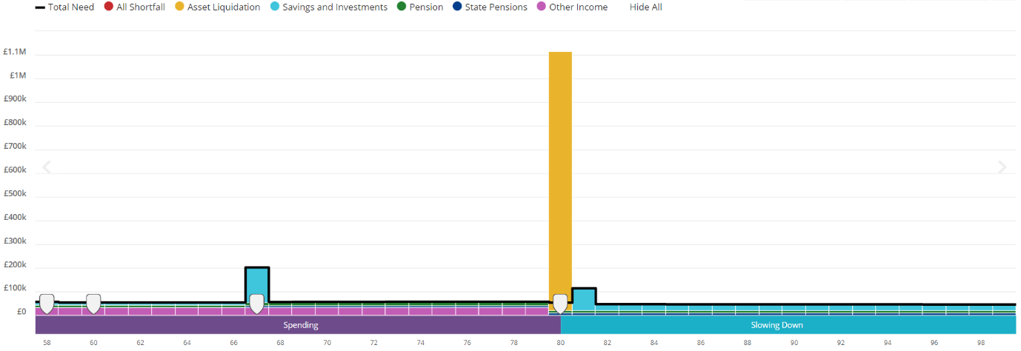

Scenario 1 – Current Situation – Liquid Assets
This chart shows how the value of your liquid assets (assets that can more easily be sold), may change over time.
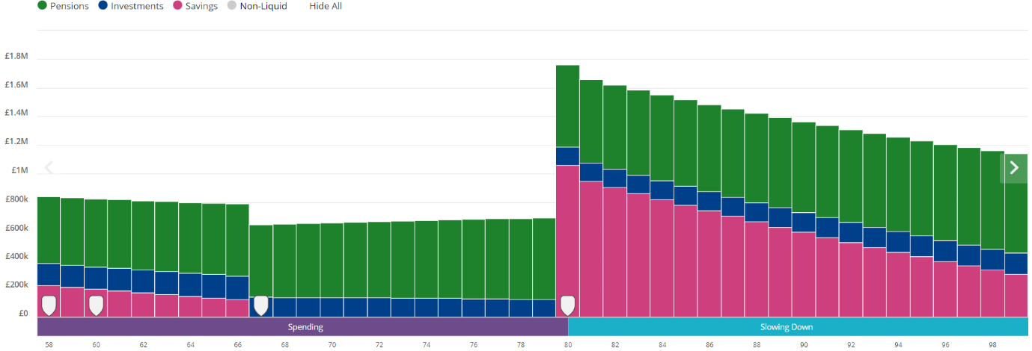

Scenario 2 – Sell Buy-to-Let Flat and Invest Proceeds - Cashflow
This chart shows how your cashflows might look if you were to sell the buy-to-let property in 2024 instead of at age 80, raising proceeds of £1,093,204, which are then invested for retirement. The figures are all shown in today’s terms and have been adjusted to consider the assumed rate of inflation.

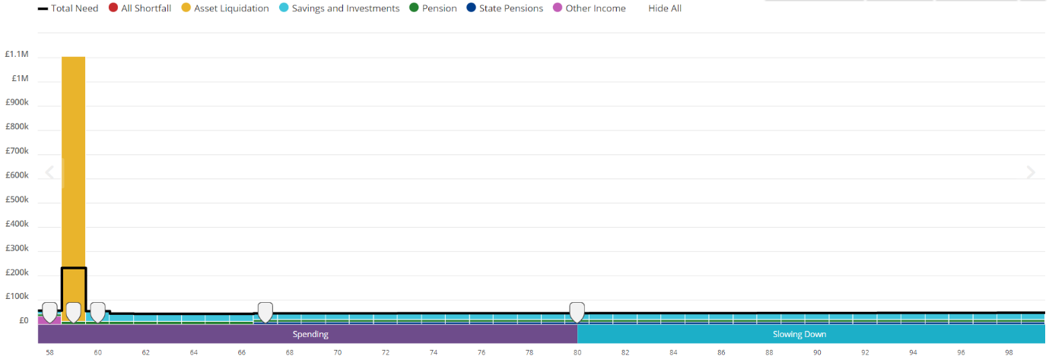

Scenario 2 – Sell Buy-to-Let Flat and Invest Proceeds – Liquid Assets

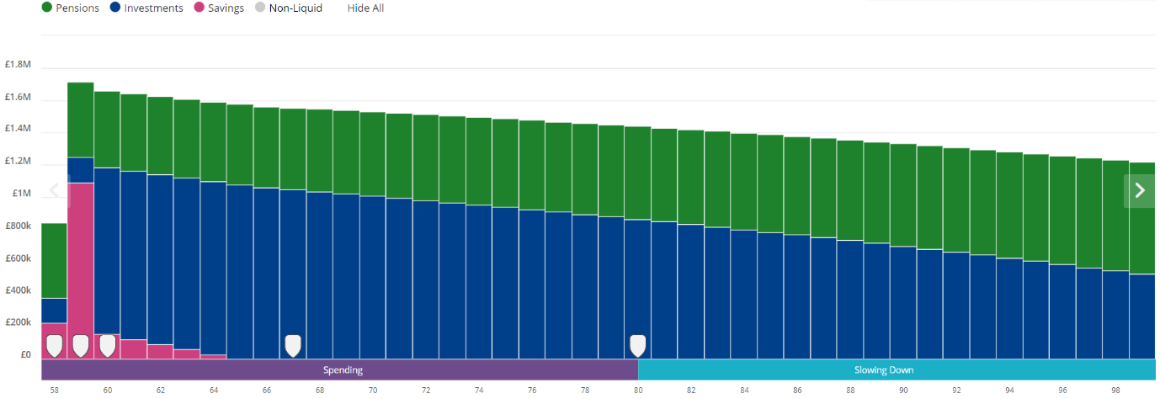

Scenario 3 – Sell Buy-to-Let Flat, Invest Proceeds & Extra Spending on ‘Wild Living’ - Cashflow
As in scenario 2, this scenario assumes that you sell the buy-to-let property in 2024, raising proceeds of £1,093,204, which are then invested for retirement. However, scenario 3 also assumes that £30,000 is spent each year in retirement on ‘wild living’ until age 80. The figures are all shown in today’s terms and have been adjusted to consider the assumed rate of inflation.
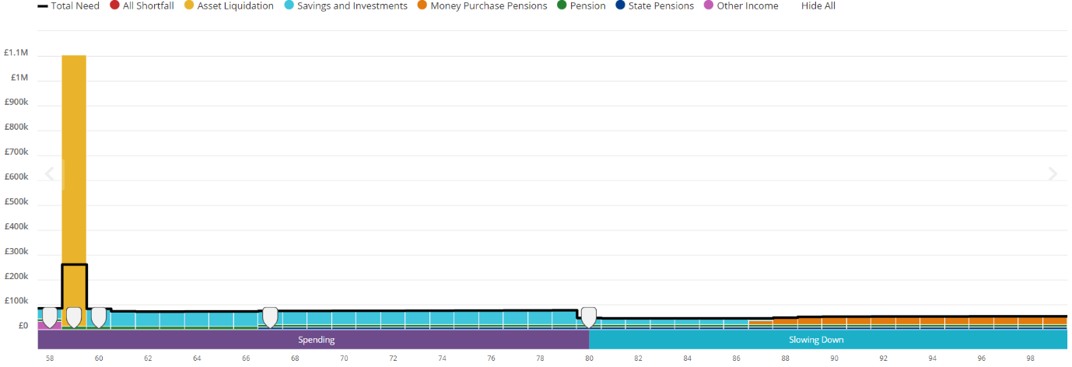

Scenario 3 – Sell Buy-to-Let Flat, Invest Proceeds & Extra Spending on ‘Wild Living’– Liquid Assets
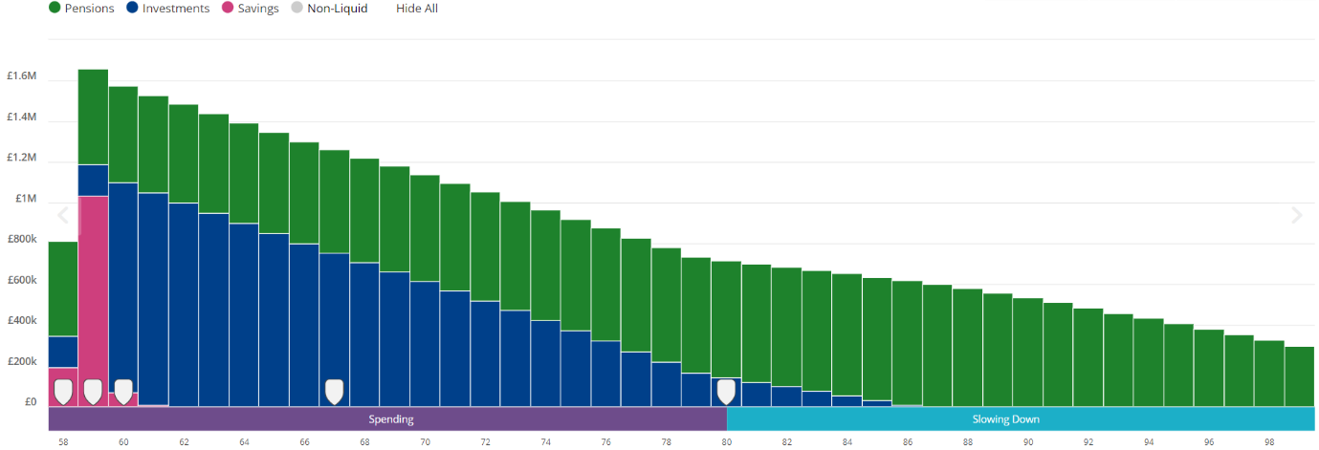

Scenario 4 – Major Loss, Followed by Selling BTL Flat and Investing Proceeds - Cashflow
Scenario 4 considers the effect of a major loss of 20%. As above, scenario 4 also assumes that the buy-to-let property is sold in 2024, and the proceeds are invested. The figures are all shown in today’s terms and have been adjusted to consider the assumed rate of inflation.

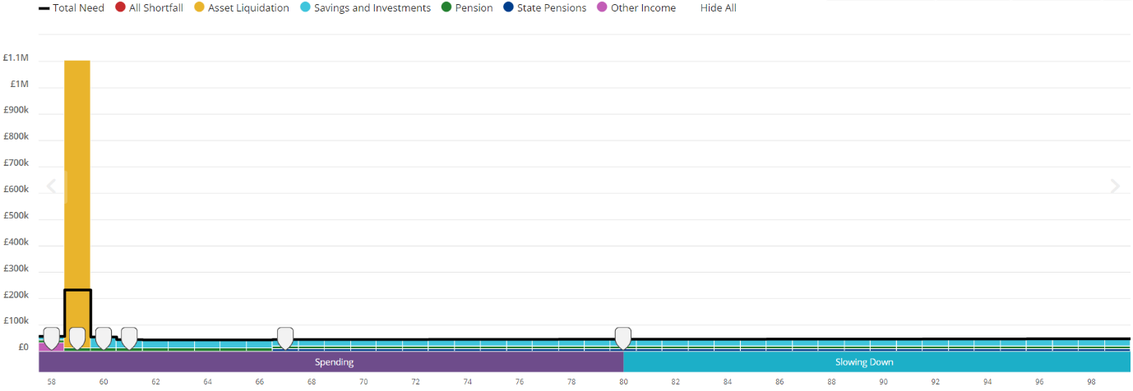

Scenario 4 – Major Loss, Followed by Selling BTL Flat and Investing Proceeds – Liquid Assets

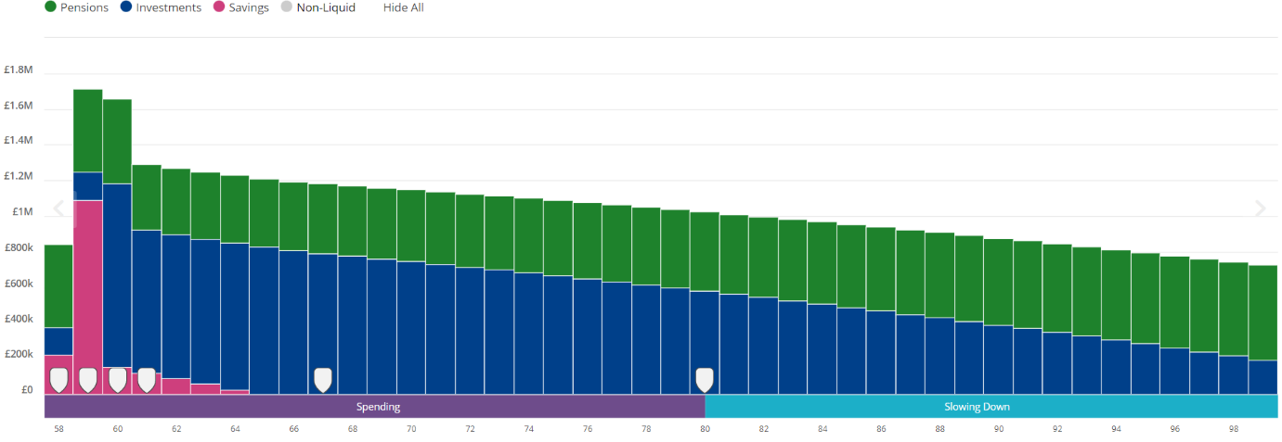

Key Observations
I have detailed the key observations which can be seen from these charts below:

Current Situation
Your assets should be sufficient to provide your desired income of £48,120 until you reach age 80, before reducing to approximately c.£41,771 in later life.
Cashflow analysis suggests that liquid assets will not run out. We estimate that approximately £1,139,043 will remain at age 100.
The current situation assumes that the buy-to-let property is sold in 2045, for proceeds of £1,093,204.

Sell Buy-to-Let Flat and Invest Proceeds
Scenario 2 differs from the above as it assumes you sell the buy-to-let property in 2024, and invest the proceeds for retirement.
Assets should be sufficient to provide your desired income of £48,120 until you reach age 80, before reducing to approximately c.£41,771 in later life.
Releasing capital from the property and investing the proceeds, should mean that you will have greater resource in terms of liquid assets throughout retirement. Investing the proceeds earlier in retirement will also allow more potential for growth of funds. Although this could reduce the possibility for making a capital gain through the flat increasing in value.
We estimate that liquid assets of approximately £1,216,078 will remain at age 100.

Sell Buy-to-Let Flat, Invest Proceeds & Extra Spending on ‘Wild Living’
As above, scenario 3 assumes that the buy-to-let is sold, and the proceeds are invested. However, this scenario also accounts for extra spending of £30,000 on ‘wild living’, until age 80, when expenditure is reduced to £41,771.
Cashflow analysis suggests that you can afford to enjoy retirement by increasing spending by £30,000, from now until age 80, without being faced with any shortfall to age 100.
Your assets will be depleted faster than in the previous scenarios, on account of the increased spending. However, cashflow analysis predicts that there will still be liquid assets of £293,853 remaining at age 100.

Major Loss, Followed by Selling Buy-to-Let Flat and Investing Proceeds
Scenario 4 assumes that your portfolios suffer a major loss of 20% in the current tax year. As above, the scenario also assumes that the buy-to-let is sold in 2024, and the proceeds are invested.
The major loss is applied on top of the market slump of 2022. The scenario also does not consider any potential recovery of assets. Whilst a loss of this magnitude is unlikely, it serves as a good ‘stress test’.
Cashflow analysis suggests that your portfolios can withstand a loss of 20% and still provide your desired expenditure without shortfall, until age 100.
Cashflow analysis predicts that assets of £725,118 will remain at age 100, even when considering a major loss at the beginning of the timeline.

Conclusion
In summary, I feel the main conclusions of our cashflow planning exercise are as follows:

- Financial Independence - From the scenarios modelled above, you are likely to have sufficient capital in place to allow you to enjoy your desired basic and discretionary expenditure in retirement. Due to your level of wealth, you should be able to increase your discretionary spending by approximately £30,000 (net) per annum, should you wish.

- Stress Test – We have stress tested your portfolio to help understand the resilience of this against negative influencing factors. As shown in scenario four, we have included a stress test which assumes that your portfolio suffers a major loss of 20%. I can confirm that it is unlikely that a market crash would impact you financially.

 | It is important to understand that the cashflow forecasts are based on various assumptions we believe to be reasonable based on your current circumstances and currently available evidence. The projected figures are therefore not a guarantee of future outcomes.

The next section of my report sets out a review of your existing plans and confirms whether they remain suitable to meet your objectives and risk profile, as set out above.

Recommendations
I have reviewed the following plans to ensure they remain suitable for your objectives and risk profile. I refer you to the original suitability report that was issued at the time the plans were first set up for further information as to why they were initially recommended.

Recommendation Summary
Based on your current personal circumstances, objectives, and risk profile, I confirm your existing plans remain suitable. However, I set out below my recommendations to make some minor changes to your existing plans, so they continue to remain suitable.

Recommendations
Following a review of your plans my recommendations are set out below together with the reasons behind these:

Top-up your AJ Bell Investcentre ISA by £150,000
I recommend that you invest £150,000 into your existing AJ Bell Investcentre ISA in the current 2022/23 tax year. This is to be invested in the LIFT-Invest Moderately Cautious portfolio in line with your previously stated risk profile.

As AJ Bell Investcentre ISAs are ‘flexible’, this means that the subscription will be treated as replacing the £150,000 that was withdrawn earlier in the year for the purchase of your new main residence in Nairn.

The cash has been raised by the sale of Cherry Cottage, and is affordable.
This has already been covered in short suitability letter, and you have provided your acceptance to the recommendation.

Invest Sales Proceeds into Fixed Term Deposit Accounts
The fixed rate of the buy-to-let mortgage expires in February 2024, at which point you would like to pay off the outstanding amount of £195,000.

As discussed, you would like to invest £195,000 into 1-year fixed term deposit accounts, for safekeeping of funds until the end of the mortgage fixed rate, and to benefit from competitive interest rates.

It will be your responsibility to open the deposit accounts, however I have suggested some 1-year fixed deposits by email.

I recommend spreading the £195,000 across three institutions, to ensure that each account is within the Financial Services Compensation Scheme limit. Spread equally, this will be £65,000 per deposit.

The sale of Cherry Cottage raised proceeds of approximately c.£338,000. As above, £150,000 of this amount will be invested into your ISA, £195,000 will be invested into fixed term cash deposits, and the remaining balance, approximately c.£43,000, will be kept as a cash emergency fund.

Reasons Why
The reasons why these recommendations meet your objectives:

- This will replenish your ISA, restoring the amount of money in tax efficient products.
Investing funds within your ISA increases potential for growth, and adds to retirement savings, helping you achieve your goal of meeting desired expenditure in retirement.
Investing into fixed term cash deposits will allow you set cash aside for the repayment of the buy-to-let mortgage, whilst benefiting from competitive interest rates, in a low-risk environment.

Disadvantages
The main disadvantages associated with these recommendations are:

- Investing into markets exposes you to capital risk.
Investing into markets puts some risk on capital, and you may get back less than you put in.

Fixed term deposit withdrawal penalties.
Funds invested into a fixed term deposit cannot be withdrawn before the end of the term without penalty.

What are the risks associated with your plans and/or our recommendations?

Past performance is no guarantee of future returns.
The price of funds and the income from them can fall as well as rise.
You may receive back less than you invest.
Funds that are invested wholly or partly outside of the UK may be subject to exchange rate fluctuations.
The tax treatment of your plans may change in the future.
On any funds that are managed outside of the UK, you are unlikely to be protected by the Financial Services Compensation Scheme (FSCS) or the Financial Ombudsman Schemes (FOS). This may make it more difficult to claim compensation or make a complaint if there is ever an issue. This does not impact your protection under these schemes for the advice LIFT-Financial provide you or any UK based products or funds you hold.
Governments can and do change the rules on tax efficient vehicles, like ISAs.
An ISA is not a risk free product and the value of the ISA investment may be at risk due to the investments held within the wrapper.
If you leave the UK and are no longer a UK resident then you can keep the ISA investment with its tax advantages but you can’t make any new contributions to the ISA.
ISA investments are liable to Inheritance Tax on death (except those eligible for Business Relief). Income Tax deducted at source on foreign dividends may be recoverable. There are no further Income Taxes to be paid on investments held within an ISA.

Cash Account Minimum Balance
I recommend that you leave the following cash balances to provide for the fees associated with your plans:

ISA - 0.50% of the plan value in Funds and Shares Cash
SIPP - 0.50% of the plan value in Funds and Shares Cash and £4,800 in SIPP cash

An annual fee of 0.30% plus VAT will be levied against your account. The charge will be calculated and deducted from your account at the end of each calendar quarter and paid in arrears. This fee has been benchmarked against similar managed portfolio services available through AJ Bell and is competitive. This will be kept under review to ensure that we remain in line with our peers.

What Are The Charges

What are the costs associated with my recommendations?
The table below summarises the cost associated with your plans after the recommendations have been implemented. Some plans remain unchanged and so the table simply outlines the existing charge that applies.

 | Initial |  | Ongoing (per annum)
Adviser Fees | £ | % | £ | %
Fees paid direct from client | £0 | 0.00% | £0 | 0.00%
AJ Bell Investcentre SIPP | £0 | 0.00% | £3,200 | 0.68%
AJ Bell Investcentre ISA | £0 | 0.00% | £1,000 | 0.66%
AJ Bell Investcentre GIA | £0 | 0.00% | £0 | 0.00%
Subtotal | £0 | 0.00% | £4,200 | 0.68%
Platform Fees
AJ Bell Investcentre SIPP | £0 | 0.00% | £702 | 0.15%
AJ Bell Investcentre ISA | £0 | 0.00% | £226 | 0.15%
AJ Bell Investcentre GIA | £0 | 0.00% | £2 | 0.15%
Subtotal | £0 | 0.00% | £930 | 0.15%
Investment Fees
AJ Bell Investcentre SIPP | £0 | 0.00% | £4,982 | 1.06%
AJ Bell Investcentre ISA | £0 | 0.00% | £1,601 | 1.06%
AJ Bell Investcentre GIA | £0 | 0.00% | £0 | 0.00%
Subtotal | £0 | 0.00% | £6,583 | 1.06%
Grand Total | £0 | 0.00% | £11,713 | 1.89%

Based on investing a total of £620,153 across the recommended 3 policies over a 5 year period, with an expected return of 4.00% compound per year, the final value would be £691,069. This is the equivalent to a total return of 11.44% after charges.

If fees were not charged to your portfolio, the projected future value over the same period would be £754,510, equivalent to a total return of 21.67%. Based on these assumptions, the total fees charges to your portfolio over this period would be £58,565, £0 at the outset and £58,565 in total through ongoing fees. This equates to a reduction in return of 10.23%.

Please note that this is only a projection and not a guarantee of the charges to be levied. This does not account for any withdrawals or contributions that you make over the upcoming year.

AJ Bell will send you an annual Costs and Charges Statement around April/May each year. This will confirm the actual costs and charges deducted within each of your accounts held on the AJ Bell platform for the previous calendar year, broken down between platform, investment and adviser costs.

 | Please note the figures in the above table are as at 18th January 2023 and due to the timing of the valuations used these may differ to the figures elsewhere in the report. Furthermore, due to rounding, the amounts and percentages may not add up precisely or reflect the absolute figures.

The effect of costs and charges on your returns
The above illustration is based on the amount you have invested and the charges that apply to the products and services today. The investment performance is not guaranteed, and the value of your investments can go down as well as up.

These figures are only examples and are not guaranteed - they are not minimum or maximum amounts. What you get back depends on how your investments grow, the tax treatment of the fund and your own tax position. You could get back more or less than the figures shown. You may get back less than the amount you have paid in.

Review of our service
As you know, AAI is a fee-based practice. We set our charges by looking at the amount of time it will take us to provide the advice and service, the complexity of the work and the risk associated with the advice that we are giving.

You have already signed our Service and Fee Agreement which confirms the fees we will charge and the service we provide, but for clarity, our ongoing fee as is as follows:

Ongoing Advice Fees | £4,200 p/a | £800 per quarter from your SIPP, and £250 per quarter from your ISA.

Other Areas of Planning

Wills
The main purpose of writing a will is to ensure that, upon death, your estate is passed to the people you want to benefit from it. It also makes the distribution of your assets simpler, reducing the stress and financial hardship that may fall upon your family and loved ones.

You told us that you do have a valid will in place. I recommend you ensure this is kept up to date to ensure your estate is passed to the people you want to benefit from it.

Lasting Power of Attorney
A Lasting Power of Attorney (LPA) ensures your health and financial affairs will be looked after by someone you trust if you cannot manage this yourself.

You told us that you have already set up a lasting power of attorney. However, this was a number of years ago, and may need updating. I recommend you keep this under regular review.

Inheritance Tax Planning
Inheritance Tax (IHT) is payable on death at a rate of 40% by those whose personal estates exceed £325,000. There is also a ‘Residence’ Nil Rate Band, which applies when you gift your main residence to direct descendants, and this will draw a further £175,000 (for 2022/23) out of the calculation if your estate is under £2m. Above this amount, the allowance tapers down at £1 for every £2 of net estate.

Based on your current assets, you will have an individual inheritance tax liability. As your income and assets grow, IHT mitigation may be an area that you need to consider in the future. However, you do not wish to address this at this time.

Long Term Care Planning (2022/23)
The average cost of a care home place in the UK is about £36,608 a year, rising to £46,176 if nursing care is required. This is likely to be significantly more if you live in the South East of England.

Each local authority has an amount that they make available to pay for an individual’s residential or nursing care, assuming they qualify for funding. Typically, the amount available is significantly less than the care home charges a self-funding resident. Any difference in the actual cost of care and the amount that the local authority is prepared to pay will usually have to be met personally. Alternatively, you would have to move to a home within the funding level of the Local Authority.

Therefore, care home fees may create a significant ‘dent’ to your finances in later life or reduce the amount you are able to pass on to loved ones. Whilst this is not a priority for you now, there are solutions available that can help to mitigate the potential cost of long-term care in later life if this becomes a concern.

Next Steps
The next steps and actions required are as follows:

- Please review this report and come back to me with any questions or comments.

- The following documents are referred to elsewhere in the report and should be kept for your records:

Appendix - Risk Profile Assessment

Your understanding of the risks involved in investing
It is important that when making decisions in relation to your financial planning you are aware of and fully understand the potential risks involved. The three key risks associated with investing are:

Capital risk – not getting back as much of your money you originally invested or losing some of the return already achieved.
Income risk – where you are investing for income, the risk that the income level achieved is less than you had expected.
Liquidity risk – not being able to get your money back when you need or want it.

When making an investment and during the time you hold it you need to take account of these risks and the consequences they may have on the achievement of your objectives. To determine an appropriate investment strategy for you, we consider the following five points in relation to your risk profile:

1. Risk required
We have talked with you to understand your goals, current and anticipated income and expenses, and current and anticipated assets and liabilities. We have discussed the return needed to meet your future cash flow needs.

2. Risk capacity
Your risk capacity (or capacity for loss) refers to your ability to manage financially if a loss occurs. This was considered during our discussions and our assessment of your financial position (including a review of your income, expenditure, assets and liabilities). We discussed the effect the loss of any invested capital would have in relation to your standard of living and/or your future objectives.

3. Risk tolerance
Unlike risk required and risk capacity, which are financial calculations, risk tolerance is psychological. Risk tolerance is how you feel about taking risk. For example, you may say that it is very important that your investments maintain their purchasing power or that any fall in the value of your investments would make you feel uncomfortable. We asked you to complete a questionnaire as a starting point to assess your risk tolerance, and discussed any inconsistences in the answers you gave to establish your natural inclination to take investment risk

4. Time Horizon
The level of risk you take is dependent on how long you are able to invest your money for. Generally speaking, the longer you can invest for, the more time you have to recover any capital losses. It is therefore important that the chosen risk profile reflects the timeframe for investment.

5. Your knowledge & experience of financial products
Knowledge and experience is about assessing what your previous experience has been in respect of financial products and investments. For example, we consider what financial products you have previously purchased and whether you have done this having received advice or whether you acted on your own. This helps us to assess your understanding of financial products and investments and the risks involved in any proposed recommendations.

Risk Descriptions
We use five different descriptions to categorise your risk profile once assessed. I have noted these below for reference:

Cautious - You are prepared to take only a small amount of investment risk and it is important to you that your capital is protected. This means that your portfolio will concentrate on investments which provide low returns in the long term but present less risk to your capital. Only a small proportion of riskier assets will be included in your portfolio in order to increase the chance of obtaining better long term returns. A typical Cautious investor will be invested mostly in fixed interest type investments, with a small element (up to about one third) in equities and property which can boost longer term returns but are associated with more risk. The range of assets provides diversification benefits which also help to reduce the overall risk.

Moderately Cautious - You are prepared to take a limited investment risk in order to increase the chances of achieving a positive return but you only want to risk a small part of your capital to achieve this. A typical Moderately Cautious portfolio will have up to half invested in fixed interest products which are low risk but have low returns. The remainder of the portfolio will be invested in equities and property which can boost longer term returns but are associated with more risk. The range of assets provides diversification benefits which also help to reduce the overall risk.

Moderate - You are prepared to take a moderate amount of investment risk in order to increase the chance of achieving a positive return. Capital protection is less important to you than achieving a better long term return on the investment. A typical moderate investor will usually invest in a variety of assets to obtain diversification. There would typically be a higher proportion of equities and property assets compared to fixed interest. The range of asset types helps reduce the overall risks as well as increasing the chance of better returns.

Moderately Adventurous - You are prepared to take an above average degree of risk with your investments in return for the prospect of improving longer term investment performance. Short term capital protection is not important to you and you are willing to sacrifice some long-term protection for the likelihood of greater returns. A typical Moderately Adventurous investor will be invested mainly in equities but with other assets included to provide some diversification. There will be a higher proportion of overseas equity within the portfolio.

Adventurous - You are prepared to take a substantial degree of risk with your investments in return for the prospect of the highest possible longer term performance. You appreciate that over some periods of time there can be significant falls, as well as rises, in the value of your investment and you may get back less than you invest. This strategy holds significant risk in the shorter term. A typical Adventurous investor will be invested almost entirely in equities, both in the UK and overseas, with a small core holding in property assets to provide some limited diversification. There may be a significant proportion of the investment in overseas and specialised equities.

Appendix - Your Existing Plans
The tables below provide a summary of your existing plans. These were discussed in our Annual Review meeting in terms of their performance and whether they meet your preferences and needs.

Stacey Shipman AJ Bell Investcentre
Account Type | ISA
Plan Number | SCC852386ISA

Fund | Holding | Value
abrdn UK Mid Cap Equity K Acc | 0.98% | £1,443.52
Allianz Contl Ep S | 1.49% | £2,191.09
Artemis Corporate Bond I Acc GBP | 14.85% | £21,801.34
Artemis SmrtGARPGlbEq I Acc | 0.52% | £762.97
Baillie Gifford European B Acc | 1.52% | £2,225.82
CT RspUKEq B Acc | 2.00% | £2,935.49
Fidelity Asia W Acc | 2.04% | £2,988.71
FP Foresight UK Infra Inc A Acc | 3.46% | £5,076.28
Funds&SharesCash | 0.56% | £825.15
Fundsmith Equity I Acc | 2.04% | £2,993.81
iShares NthAmrcnEqIndx(UK) D A | 4.04% | £5,935.99
Janus Henderson SgBd I A | 14.76% | £21,672.55
JOHCM UK Dynamic Y Acc | 2.98% | £4,376.75
JPM Emerging Markets C Acc | 1.02% | £1,504.86
JPM US Equity Income C Hg Inc | 1.97% | £2,896.22
L&G Sht Dtd Stg Corp Bd Idx I Acc | 4.99% | £7,324.71
LF Lindsell Train UK Equity Acc | 5.49% | £8,065.30
M&G Optimal Income PP A £ | 6.44% | £9,460.62
Premier Miton EuOpp F A£ | 2.00% | £2,936.01
Premier Miton USOpps B A£ | 8.46% | £12,420.54
T. Rowe Price Jap Eqty C9 A | 1.54% | £2,256.54
TwentyFour Corporate Bond I Acc GBP | 10.98% | £16,120.94
UKGlts0-5UETF 0 5 | 0.94% | £1,375.55
Vanguard UKGvtBdIx A£ | 4.93% | £7,240.98
Total: | 100.00% | £146,831.74
Fund values as at 10/03/2023.

Stacey Shipman AJ Bell Investcentre
Account Type | SIPP
Plan Number | SCC852386SIPP

Fund | Holding | Value
abrdn UK Mid Cap Equity K Acc | 0.98% | £4,552.72
Allianz Contl Ep S | 1.51% | £7,038.65
Artemis Corporate Bond I Acc GBP | 14.69% | £68,368.55
Artemis SmrtGARPGlbEq I Acc | 0.52% | £2,409.66
Baillie Gifford European B Acc | 1.52% | £7,094.66
CT RspUKEq B Acc | 1.99% | £9,240.87
Fidelity Asia W Acc | 2.02% | £9,399.77
FP Foresight UK Infra Inc A Acc | 3.46% | £16,108.85
Funds&SharesCash | 0.52% | £2,424.66
Fundsmith Equity I Acc | 2.04% | £9,491.73
Investcentre SIPP Cash Account | 0.40% | £1,876.23
iShares NthAmrcnEqIndx(UK) D A | 4.02% | £18,699.33
Janus Henderson SgBd I A | 14.78% | £68,764.86
JOHCM UK Dynamic Y Acc | 2.94% | £13,679.60
JPM Emerging Markets C Acc | 1.02% | £4,738.19
JPM US Equity Income C Hg Inc | 1.97% | £9,144.36
L&G Sht Dtd Stg Corp Bd Idx I Acc | 4.98% | £23,179.56
LF Lindsell Train UK Equity Acc | 5.49% | £25,539.60
M&G Optimal Income PP A £ | 6.42% | £29,868.38
Premier Miton EuOpp F A£ | 1.98% | £9,204.43
Premier Miton USOpps B A£ | 8.43% | £39,212.92
T. Rowe Price Jap Eqty C9 A | 1.54% | £7,143.86
TwentyFour Corporate Bond I Acc GBP | 10.87% | £50,578.25
UKGlts0-5UETF 0 5 | 0.97% | £4,501.80
Vanguard UKGvtBdIx A£ | 4.96% | £23,072.48
Total: | 100.00% | £465,333.97
Fund values as at 10/03/2023.

Stacey Shipman AJ Bell Investcentre
Account Type | General Investment Account
Plan Number | SCC852386DA

Fund | Holding | Value
Funds&SharesCash | 100% | £1,356.09
Total: | 100.00% | £1,356.09
Fund values as at 10/03/2023.

Expression of Wish
Since the 6th April 2015, the flexibility and tax treatment of death benefits from UK-registered pension schemes has evolved for the better making it essential for the nomination of beneficiaries to be considered closely in conjunction with the new regime.

In summary, the tax treatment is as follows:

- On death before age 75, benefits can now be paid as a lump-sum or as a drawdown pension to any beneficiary tax-free, irrespective of whether these benefits derived from uncrystallised or crystallised funds.

- On death after age 75, the benefits can be drawn as an income or a lump sum at the beneficiary’s marginal rate of Income Tax.

The rules allow for any beneficiary to elect for either income or a lump sum; an obvious advantage being that any remaining funds following the death of the first beneficiary may be passed on to further nominated beneficiaries. Theoretically, this allows for the fund to be continually preserved through multiple generations until exhausted.

The decision regarding who you would like to benefit can be changed at any time with a subsequent expression of wish form, superseding any previous nomination.

Appendix - Product Information
We have selected tax wrappers or financial products based on your tax position and unused allowances, and objectives including timescales. Our choice of product and provider on your behalf is based on independent research which we maintain centrally and is kept on file.

Financial Services Compensation Scheme (‘FSCS’)
Any UK regulated savings or current account (including Cash ISAs) held in banks, building societies or credit unions are covered by the Government backed Financial Services Compensations Scheme (FSCS). If the organisation holding your cash savings should fail, each individual would be entitled to £85,000 compensation per person, per financial institution. It is, therefore, advisable not to hold more than this amount with one banking institution.

You should also bear in mind that some banking institutions may have a number of banks within their organisation with only one licence covering all banks.

The FSCS will also provide a £1 million protection limit for temporary high balances held with your bank, building society or credit union if it fails. Further details can be found at www.fscs.org.uk.

Investments
If you need to grow your money over the medium to long term, and once you’ve got an adequate emergency cash reserve in place, you will probably need to consider some type of investment. Investments differ from cash savings in that they provide higher returns in exchange for the risk of capital loss.

Recommended Product – What is an Individual Savings Account (ISA)?
The Individual Savings Account (ISA) is a tax-free savings account which means there is no liability to Income or Capital Gains Tax within the wrapper or upon encashment.

ISA savers will be able to subscribe the full amount to a cash account and will be able to transfer their investment from a ‘Stocks & Shares’ wrapper to a ‘Cash’ wrapper and vice versa.

Recommended Product – What is a General Investment Account (GIA)?
A GIA operates in a similar way to an ISA, but without the tax-free environment. It is simply an investment account which holds unit trusts/OEICs directly, rather than within an ISA wrapper.

Any withdrawals of capital from the account are potentially liable to capital gains tax. However, each individual has an annual allowance of £12,300 (for the 2022/23 tax year), meaning a gain of £12,300 can be made before any potential tax liability. This is an important annual allowance. Any natural income received from a GIA would be chargeable to income tax in the normal way.

An advantage of a GIA is that the fund can easily be transferred into an ISA by way of a Bed & ISA transaction in future years. As a result, any gains within the portfolio are likely to be within the capital gains allowance should the gains are realised on an annual basis.

Pensions
What is a Self-Invested Personal Pension?
A SIPP is a tax efficient investment vehicle used to provide benefits in retirement. A SIPP is a personal pension plan set up by an insurance company or specialist SIPP operator where the member has greater control over the investments. Anyone can take out a SIPP providing they meet the provider's eligibility requirements. These are usually based on a minimum fund size because of the higher costs involved in running a SIPP compared to a standard personal pension. Other features include:

The option to invest in both non-insured assets such as unit trusts and commercial property and insured assets such as a trustee investment plan.
The member's employer can contribute to the plan and may operate payroll deduction on the member's behalf.
The ability to lend to a company where members are directors or shareholders.
The ability to invest in any commercial property including one held by the SIPP member.
The ability to borrow up to 50% of its net assets to fund a property purchase.
The ability to invest up to 70% of the pension fund in any company if acceptable to the SIPP provider. However, tax charges may be applied if the company is controlled by a member or an associated person.

Retirement Options
When you start to take any benefits from your pension you typically have a number of options. The main ones are summarised below:

Pension Commencement Lump Sum (or Tax Free Cash)
25% of an uncrystallised money purchase pension fund can typically be taken as a tax-free lump sum (Pension Commencement Lump Sum), although higher amounts are available for some pension plans established prior to 6 April 2006. Withdrawals in excess of the tax-free entitlement are taxed at the individual's marginal rate of income tax.

Purchase an Annuity
A product that converts a pension fund into an income that is paid for the rest of the annuitant's life. The level of income provided is dependent upon your age, state of health and certain lifestyle choices, the prevailing annuity rate, the size of your pension fund, and the options and benefits selected at outset. In terms of payment options, the income can be paid at various intervals and can remain level or increase each year. Annuity income is treated as earned income and paid net of tax by the annuity provider.

Flexi Access Drawdown
Enables a lump sum and / or an income to be taken directly from a pension fund, whilst leaving the balance of the fund invested.

Uncrystallised Funds Pension Lump Sum
It is possible for an individual to withdraw a lump sum or series of lump sums directly from an uncrystallised pension fund. Typically, 25% of the amount paid will be tax free with the remainder taxed as income at the individual’s marginal rate of income tax.

